Executive Summary
Sue Byeon
MSDS 498 Capstone
December 2, 2025

Project Overview
The telecommunications industry powers modern connectivity, yet many providers struggle to deliver consistently high-quality field service. While customers often enjoy reliable network performance, service quality can falter when technician assignments are made using manual or basic rule-based methods that consider only availability or proximity, overlooking technician skill alignment. As a result, 42% of tasks are mismatched, contributing to a 42% failure rate across all assignments, $350,000 in annual penalty costs, and declining customer satisfaction. These inefficiencies limit scalability, reduce operational margins, and erode both technician morale and customer trust.
To address these challenges, this project proposes an Automated Technician Task Matching System. By applying data analytics and machine learning, the system will intelligently assign tasks based on technician expertise, task requirements, and historical performance. This shift from generic, reactive scheduling to personalized, predictive assignments aim to reduce task failures, minimize operational costs, and enhance customer satisfaction by improving the accuracy, efficiency, and scalability of technician-task assignments.
Data Description
Three tables used in this project were created based on datasets found in Kaggle. One dataset contains task assignments and completion records for field technicians. Each row represents a unique task assigned to a technician, capturing key attributes related to both the task and the technician’s suitability for it. Another capture detailed information about completed task assignments and their outcomes, focusing on operational logistics, task requirements, and customer satisfaction. Each row represents a single task, including attributes that describe the context of the assignment, resource needs, and the results as perceived by the customer. Both were used to create a relational database between technicians table, historical task table, and unassigned task table shown in figure 1. Had to calculate Penalty Cost and Customer Rating in the historical tasks using formula defined in unassigned dataset to reflect similar values and data behaviors. Reverse engineer Eqt Trained and Tech complexity for the technician table by deriving from Expertise match to reflect the maximum task complexity a technician can handle reliably and indicate whether the technician has experience with tasks requiring equipment.
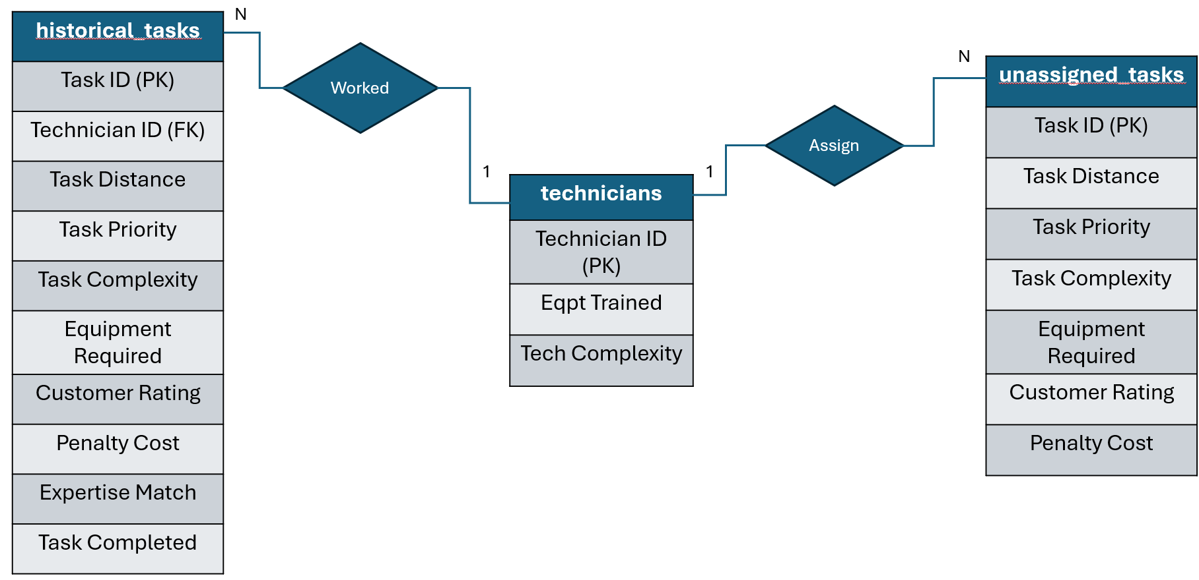
Methodology & Deliverable
The idea is to predict the probability of a technician completing a task based on their technical skills and characteristics of their past successful tasks. These features include Task Distance, Task Priority, Task Complexity, and Equipment Required, Tech Complexity, Eqpt Trained, Expertise match, customer rating, penalty cost. The model will assign the task to the technician with the highest probability. The solution uses a classification machine learning algorithm provided by Python’s XGBoost library. It is a gradient boosting method to improve prediction accuracy. It is trained on 80% of the historical tasks data and tested on the other 20%. During model evaluation phase, there was a clear bias on a couple technicians, so the model was adjusted to include a softmax-based selection process that convert tech’s probability for a task into a weighted random choice to give all techs a chance while still being probability-driven. The final model accuracy came to be 0.833 and ROC-AUC of 0.667.
The final deliverable includes a user-friendly application for managers to delegate incoming service task requests through automation shown in figure 2. It has features to view technician’s profile, their past assigned tasks, and incoming unassigned tasks shown in figure 3 and 4. It uses Python’s FastAPI to allow administrative actions like assigning tasks using the model and removing recently assigned tasks from technician’s schedule. The app also uses a robust React frontend framework to design the UI components and interact with the backend.
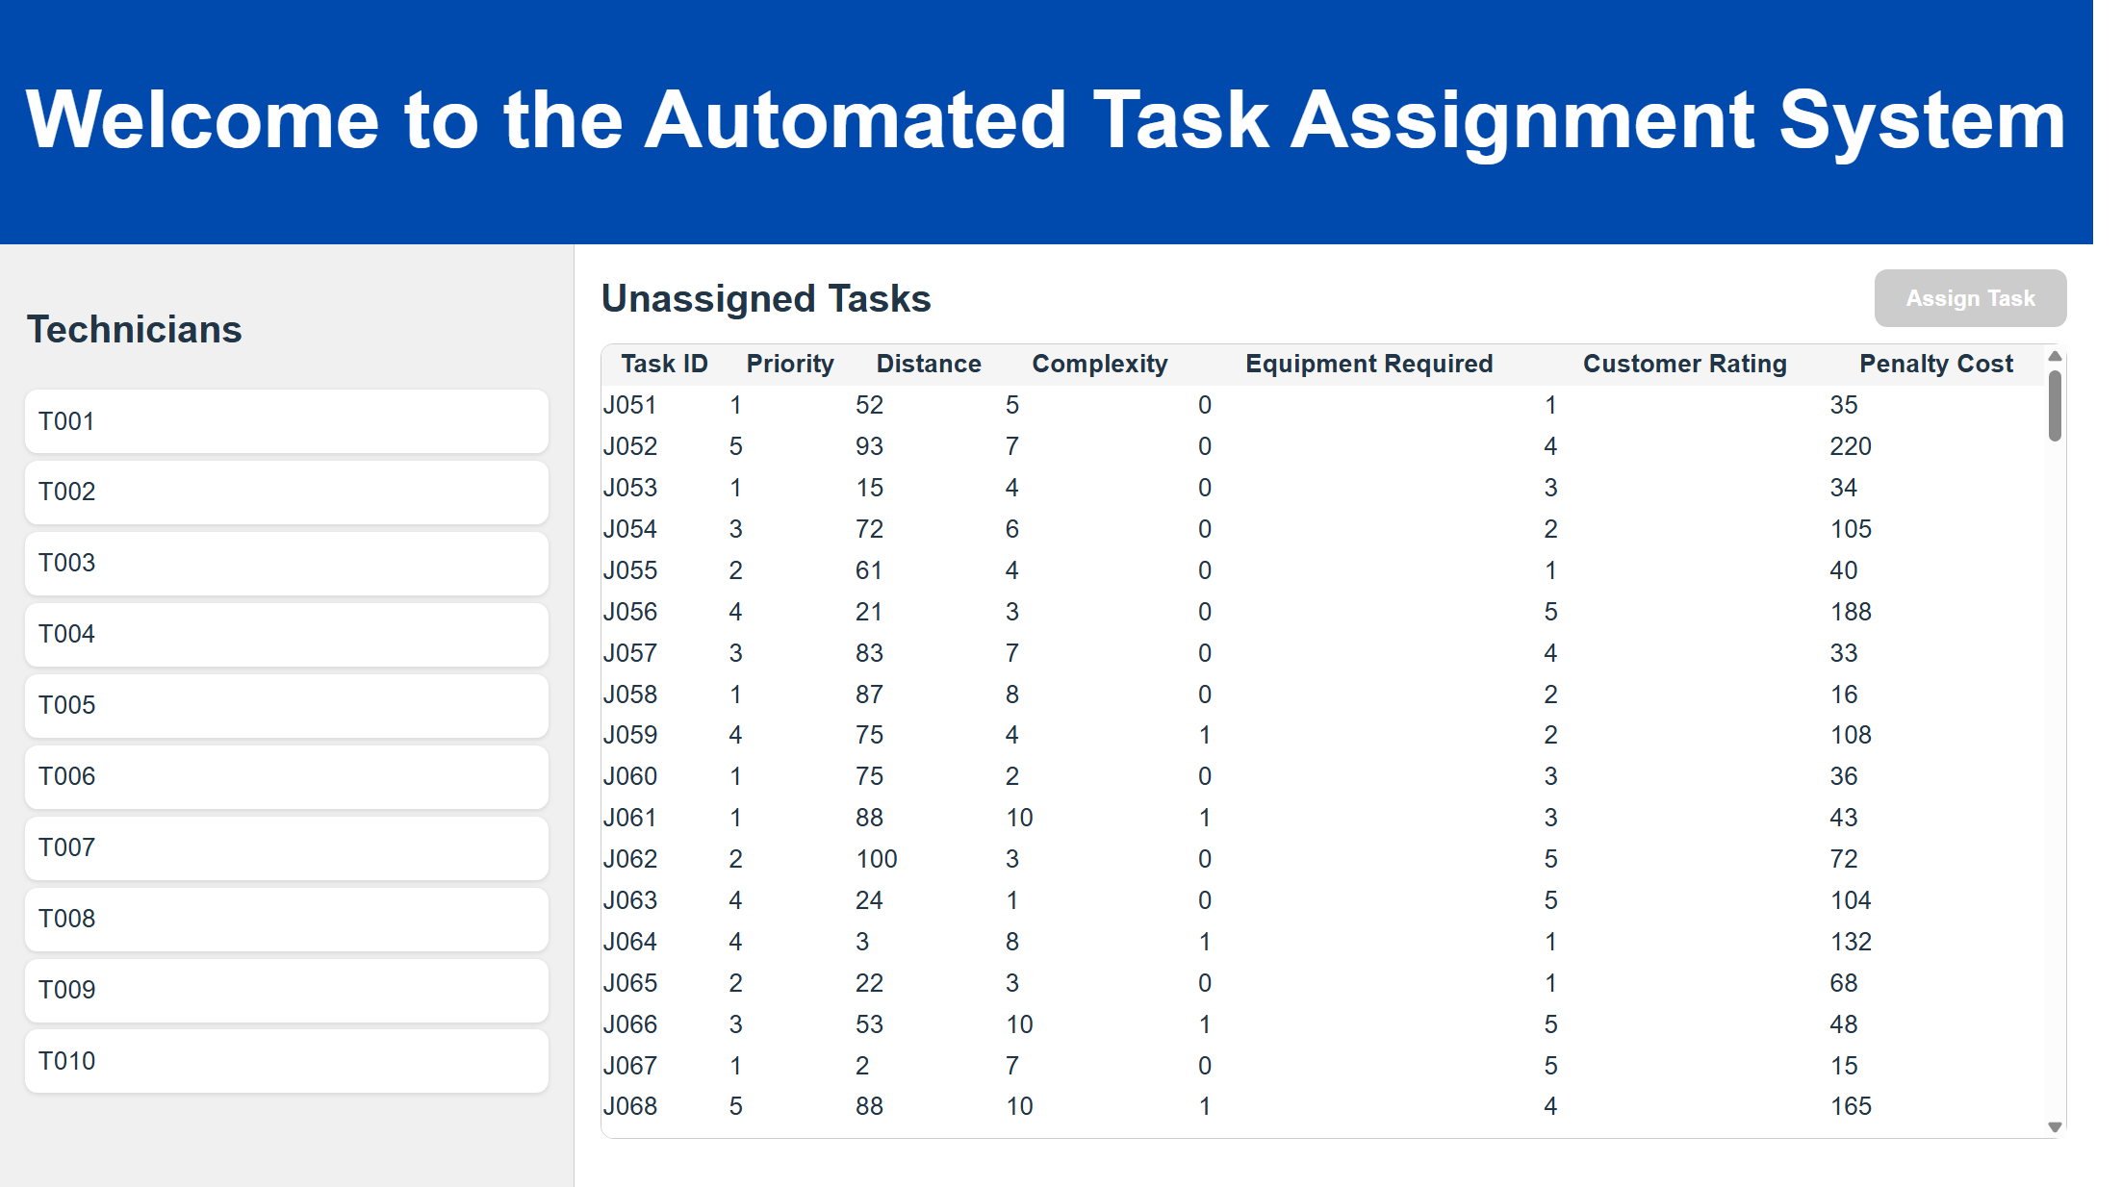

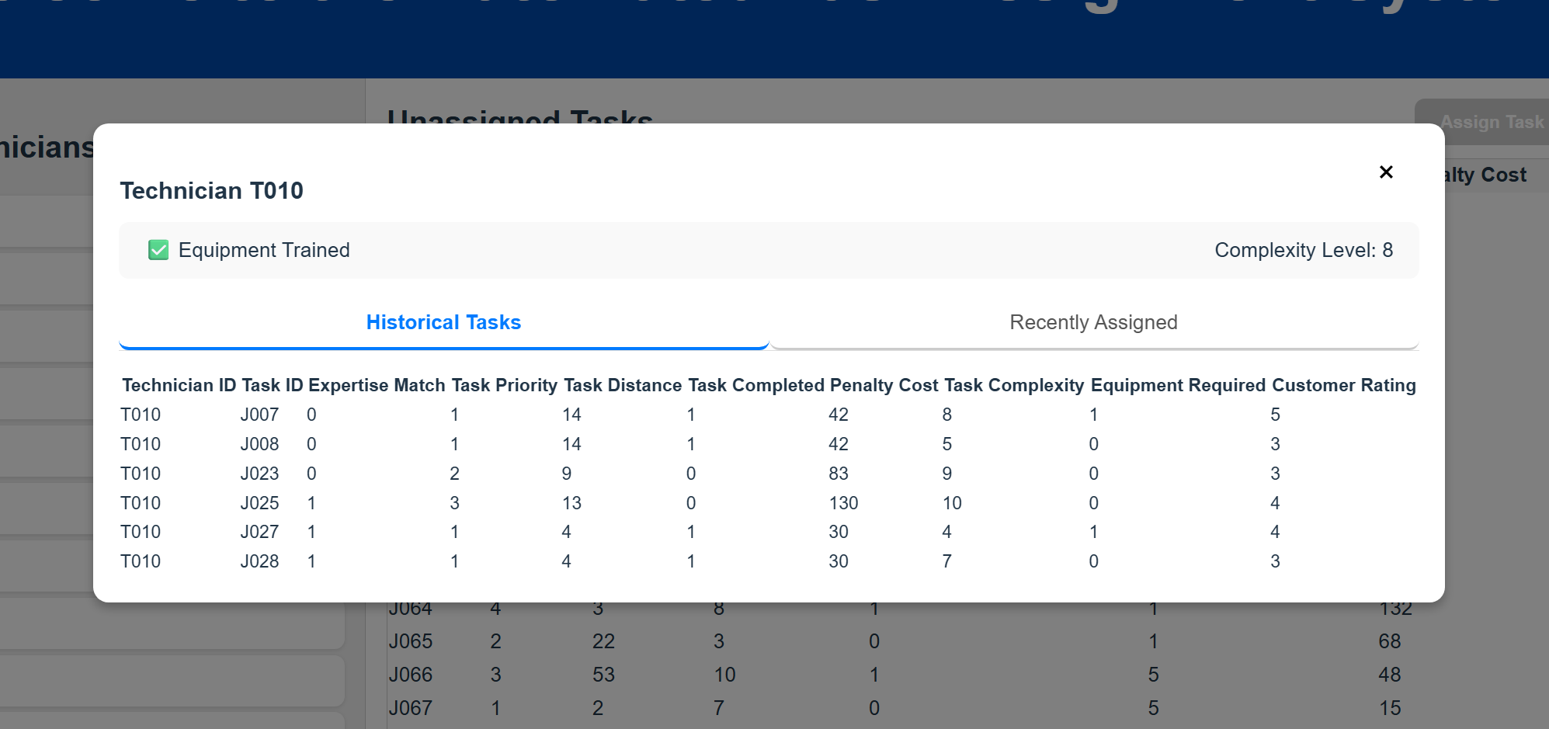
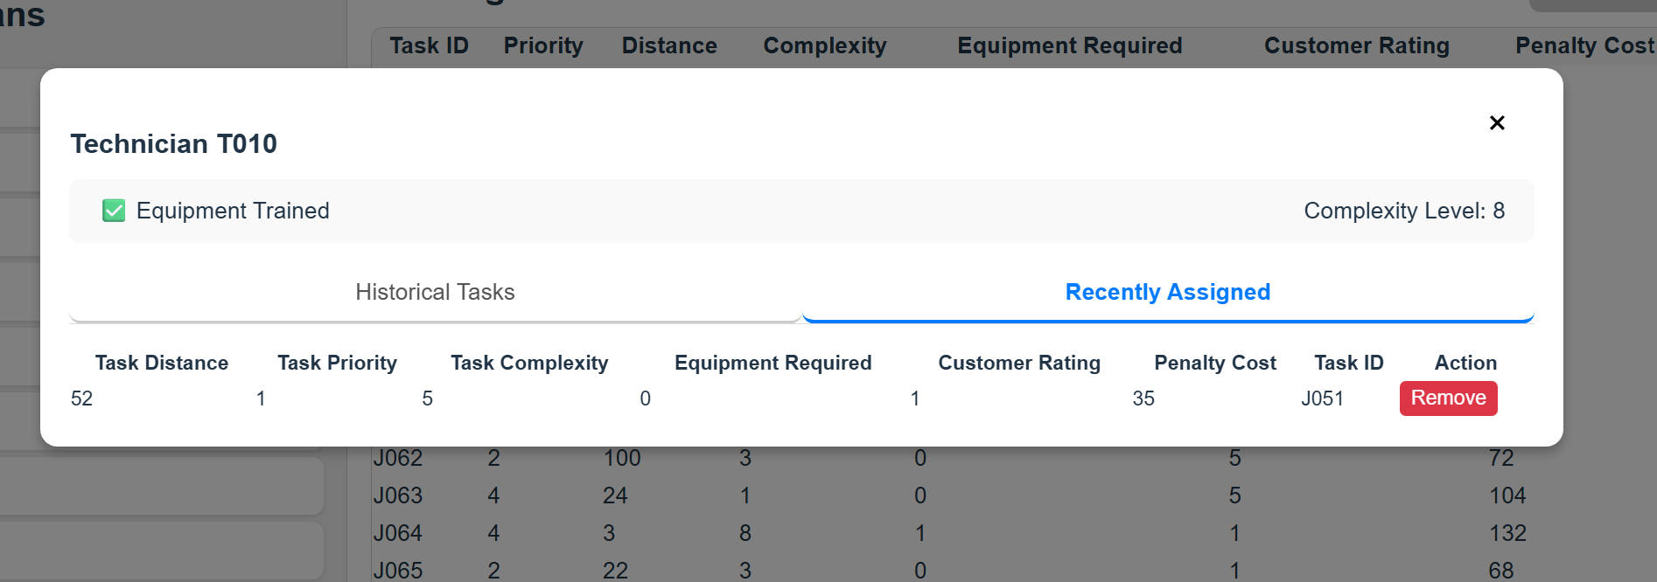
Results & Benefits
After full implementation and simulation of the solution, we noticed impressive results of the model from the old system financially, operationally, and reputationally. Final success metrics analysis shows a significant reduction of penalty cost at nearly $4.1K from $13.8K. Figure 5 shows majority of the more urgent (higher priority tasks) and 1 and 3 task complexity level is where the savings came from. Compeny benefits cuz it reduces cost accured from rework and repeat visits which takes more operational costs.
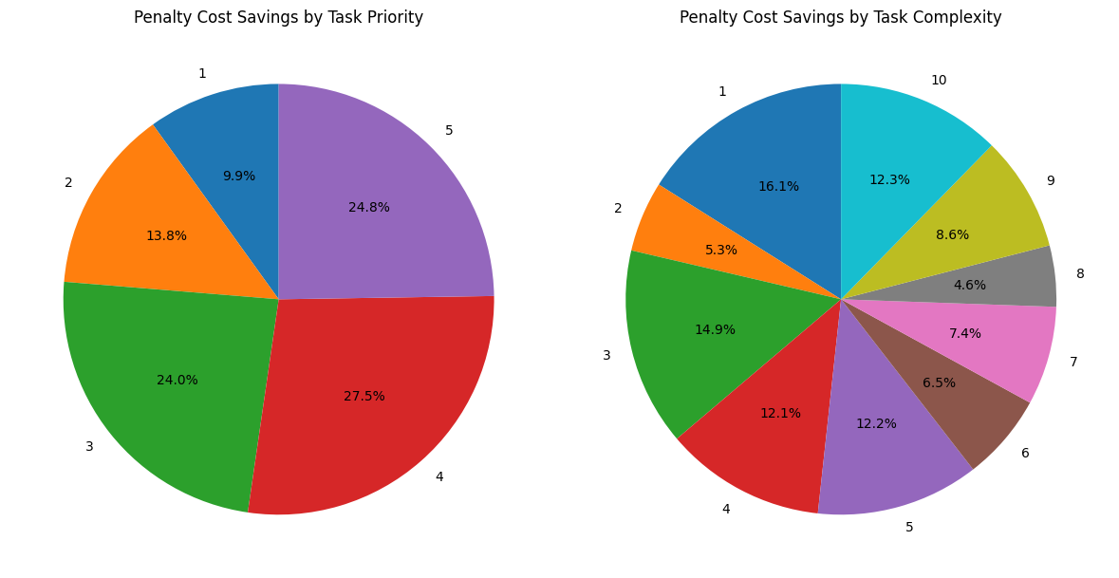
We analyzed 32% improvement in task completion rate - from 58% to 76.5%. Initially, 58% of tasks with the expertise match, other words equipment requirement for the task was satisfied and tech is sufficiently qualified in complexity of the task. Although the metric has not changed after implementation, the cross tables in figure 6 show a larger gap between expertise matched incomplete tasks vs expertise matched completed tasks, meaning of the matched tasks the system had assigned, tech were more successful in completing the task. Also shows more distinction that not expertise match tasks could not be completed than the previous system. These results show an improvement in the operational aspect as higher task completion rate leads to faster and more efficient job turnaround and higher expertise match rate means less errors made.
Before: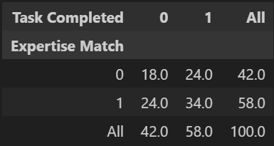 After: 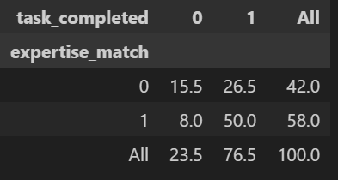
customer rating score - bar graph: show distribution of customer ratings to show left skewedness to show improvement in rating
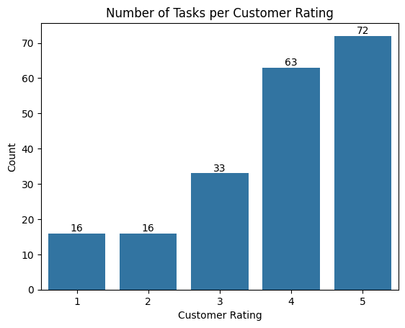
Limitations & Future Work (1/4)
Limitations involve data issues with the training dataset. The limited number of rows in the training dataset poses a challenge for building robust predictive models. With such a small training sample, the model will have fewer patterns to learn from, increasing the risk of overfitting and reducing the overall accuracy and generalizability of the results. Also, the lack of Contextual Data on Both datasets limited the depth of insights that can be drawn from the analysis and could also restrict the model’s ability. Which created a lot of difficulties during feature engineering for tech complexity and eqpt trained.
For future enhancements, collect more data to train the model more accurately. And integrate data pipeline coming from the source of where the service requests are coming from and technician platform. integrating route optimization to help simulate travel times and routing between job sites. This would provide additional geographic context and support technician scheduling within regional constraints. and incorporating dynamic, real-time considerations like sudden outages, spikes in job orders, or when a tech unexpectedly becomes unavailable.
Conclusion & Recommendations (1/4)
After testing this model, we see a great benefit in integrating this system into your work group. We recommend creating training plans and a change management plan to help managers get comfortable with this system.

Appendix A: Formal Literature Search (1)
Paper #2 focuses on generating entirely new scheduling scenarios, which is great for companies that want to completely overhaul their systems. In contrast, my project focuses on optimizing what organizations already have—ideal for companies that need incremental improvements and can’t afford to hire more technicians or make major structural changes.
Papers #1 and #3 introduce advanced optimization algorithms like Iterated Local Search to find the best overall routing and scheduling for technicians. Their main goal is to maximize company efficiency by redesigning full schedules. My approach is different: instead of optimizing the entire schedule, I predict how likely each technician is to successfully complete individual tasks. This allows more flexible and personalized task assignments based on each technician’s history.
A key difference is that my method focuses more on aligning tasks with the technician’s strengths. This is essentially making their jobs easier and setting them up for success while the other approaches primarily optimize for company outcomes. This technician-centered perspective can indirectly improve overall operational efficiency by boosting task completion rates which would also appeal to the company's goal for cost savings and increasing customer satisfaction.
A.1. Introduction
This appendix reviews recent advances in technician scheduling and task-matching systems. The objective is to identify current approaches, key findings, and how this project’s method differentiates itself by focusing on technician-level predictive matching.
A.2. Review of Existing Work
Field Technician Scheduling with Experience-Dependent Service Times (MDPI, 2023): Utilizes mixed-integer programming to optimize schedules based on technician experience and historical service times, achieving reduced average service durations.
Technician Routing and Scheduling for Tasks with Uncertain Resolution Locations (DTU, 2023): Proposes robust optimization for generating new routing scenarios, addressing uncertainty in task locations and aiming to minimize idle and travel time.
Enhanced Iterated Local Search for the Technician Routing and Scheduling Problem (arXiv, 2023): Applies advanced local search algorithms to technician routing, demonstrating improved schedule efficiency relative to basic heuristics.
A.3. Differentiation and Contribution
While prior work focuses on optimizing entire schedules or creating new systems, this project leverages predictive modeling to match individual tasks to technicians based on their historical success rates. This technician-centered approach aims for incremental, practical improvements, bridging the gap between organization-wide efficiency and individual technician performance.
My project is to develop an automated technician task-matching system that uses historical data to predict the likelihood of successful task completion and improve scheduling efficiency.
A.4. References (Provide full citations here)
1. The Field Technician Scheduling Problem with Experience-Dependent Service Times (MDPI, 2023)
2. Technician Routing and Scheduling for Tasks with Uncertain Resolution Locations (Technical University of Denmark, 2023)
3. Enhanced Iterated Local Search for the Technician Routing and Scheduling Problem (arXiv, 2023)

